
National University of Computer & Emerging Sciences, Karachi
Fall-2021 CS-Department
Re-Final Exam
25th of January 2022, 9:00 am – 12:00 pm
Course Code: CS3005 | Course Name: Theory of Automata
Instructor Name: Mr. Musawar
Student Roll No:
Instructions:
- Return the question paper.
- Attempting of the question in the given order is highly encouraged.
- Read each question completely before answering it. There are 5 questions on 7 pages.
- In case of any ambiguity, you may make assumption. But your assumption should not contradict any statement in the question paper.

Time: 180 minutes. Max Point: 100
Question 1: Miscellaneous MCQs (20 Points)
Write the solutions of MCQs on your answer sheet. Answers of MCQs on question paper would not be accepted. (YOU MAY SELECT MORE THAN ONE OPTIONS IF POSSIBLE)
1. A Finite automaton employs ________ data structure.
a) Queue
b) Linked List
c) Hash Table
d) none
2. A string is accepted by a FA when
a) Stack is not empty
b) Acceptance state
c) All of the mentioned
d) None of the mentioned
3. State true or false:
Statement: Every context free grammar can be transformed into an equivalent non deterministic finite automata.
a) true
b) false

4. Which of the following options does not resembles the given PDA? (# is stack symbol).
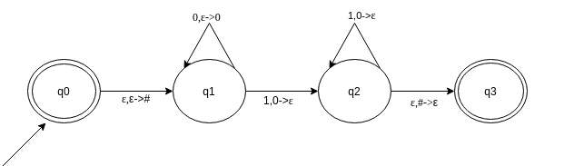
Find the option which resembles the given PDA
a) {0^{n}1^{n}|n>=0}
b) {0^{n}12^{n}|n>=0}
c) {02^{n}1^{n}|n>=0}
d) None of the mentioned
5. Which of the following are the actions that does not operates on stack top?
a) Pushing
b) Popping
c) None
d) All of the mentioned
6. Which of the following statements are true?
a) Context free language is the subset of context sensitive language
b) Regular language is the subset of context sensitive language
c) Recursively enumerable language is the super set of regular language
d) Context sensitive language is a subset of context free language
7. For S->0S1|e for ∑={0,1}*, which of the following are correct for the language produced?
a) Non regular language
b) 0^{n}1^{n} | n>=0
c) 0^{n}1^{n} | n>=1
d) None of the mentioned
8. Are ambiguous grammar context free?
a) Yes
b) No
9. Given Grammar: S->A, A->aA, A->e, B->bA
Which among the following productions are Useless productions?
a) S->A
b) A->aA
c) A->e
d) B->bA
10. Given grammar G:
S->aS|A|C
A->a
B->aa
C->aCb
Find the set of variables that can produce strings only with the set of terminals.
a) {C}
b) {A,B}
c) {A,B,S}
d) None of the mentioned
11. A Turing machine operates over:
a) finite memory tape
b) infinite memory tape
c) depends on the algorithm
12. Which of the functions are not performed by the Turing machine after reading a symbol?
a) writes the symbol
b) moves the tape one cell left/right
c) proceeds with next instruction or halts
d) none of the mentioned
13.Which of the following a Standard Turing machine does not consist of?
a) input tape
b) head
c) state register
d) none of the mentioned
14. Which of the following options does not resemble with the given Turing Machine?
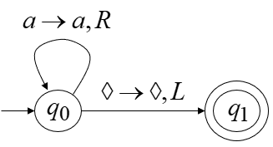
- a*
- a+
- λ
- none
15. Turing Machine accepts following languages
a) Recursively Enumerable
b) Regular Languages
c) Context Free Languages
d) Context Sensitive Languages
e) All of these
f) None of these
16. Minimum number of states required to design a DFA which accepts strings ending with 10 having alphabet {0,1}.
a) 4
b) 3
c) 2
d) can’t be represented.
17. Regular expression for all strings starts with ab and ends with bba is.
a) aba*b*bba
b) ab(a+b)*bba
c) ab(a+b) *bba+abba
d) None of the mentioned
e) All of the mentioned
18. The basic limitation of finite automata is that
a) It can’t remember arbitrary large amount of information.
b) It sometimes recognizes grammar that are not regular.
c) It sometimes fails to recognize regular grammar.
d) All of the mentioned
19. Which of the following does the given NFA represent?
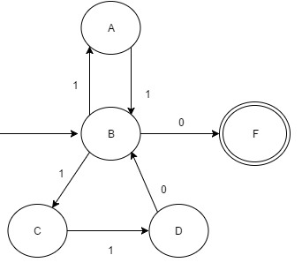
a) (11(λ+0))*
b) (110+ 01) * 11
c) (11+110) * 0
d) (00+ 110)* 1
e) a and b

20. If L is a regular language, complement and reverse of language both will be:
a) Recognized by NFA
b) Not recognized by NFA
c) One of them will be recognized
Question 2: (Regular Languages) (8+8+2+2 Points)
- Perform the union of the following DFAs.
- Perform Concatenation of following DFAs.
- Identify the languages of the following DFAs.
- Write down the regular Expressions of the following DFAs.
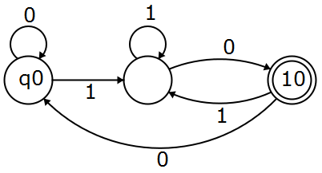 | 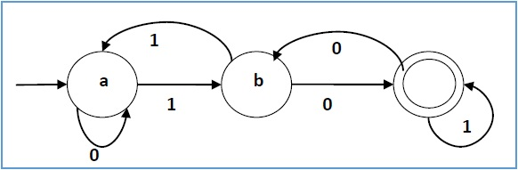
Question 3: (PDA) (5+5+5+5 Points)
- Design a PDA for even language and odd language.
- Show the stack operations for the words of your choice on each the above PDAs.
- Design a PDA for following language having equal number of 0’s and 1’s.
- Design a PDA for following language
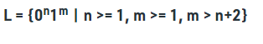
Question 4: (CFG) (5+10+5 Points)
- Write Down the CFG for following languages.
- abbbb (a+ b)+aba
- Even Length Palindrome language over alphabet ∑= {a, b}

- Simplify the following CFG and Convert the resultant CFG into CNF.
S→ASA| BSB| A | B |a| b
A→ ASA|a|b|BSB|AS|SA|S
B→ BSB|a|b|BSB|AS|SA|S
C→ASA|AS|SA|S
- Convert the following CFG into PDA
S → AB
A → aaA | ε, B → Bb| ε
Question 5: (Turing Machine) (4+4+4+4+4)
- Design the Turing Machine for abb(a+b) *010. Draw the Turing Tape and Show that whether the word 010 would be accepted by the Turing Machine or not.
- Draw Chomsky’s Hierarchy and highlight the type languages for which Turing machine can be formed. Also Elaborate the concept of the Type 0, Type 1, Type 2 and Type 3 grammars.
- Design a Turing machine for (a+b) * and discuss whether the languages {aabb, bba} and {aaa,bbb} would be accepted by this Turing machine or not.
- Discuss the concept of blank symbol in Turing machine, also discuss why Turing machine has infinite tape?
- Discuss whether Turing machines are deterministic or not? With proper example.

